**SRF WAREHOUSE 8106 FUNCTIONALITY V2**

**User’s Manual**

1. **After the approval of IMPEX in SRF, user must go to SRF Warehouse Receiving Entry (SERVICE REPAIR > TRANSACTIONS > Warehouse Receiving Entry) to check if the delivery is arrived and checking down the items for delivery.**

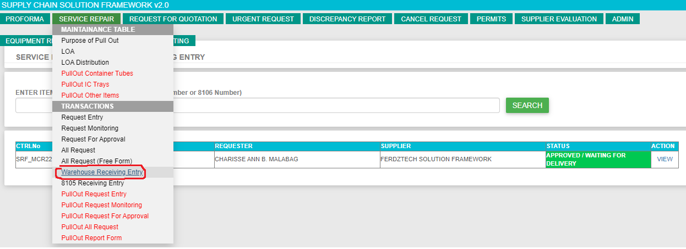

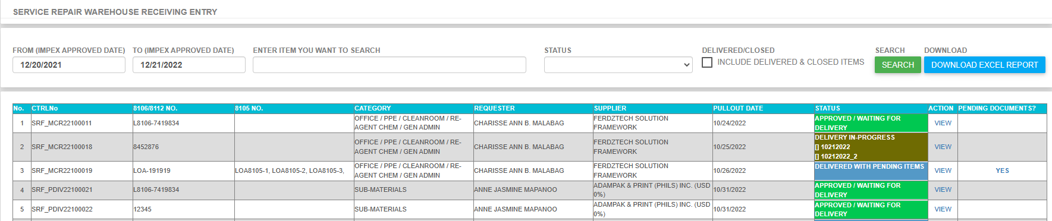

1. **By default, the status is APPROVED / WAITING FOR DELIVERY, once the user double click the VIEW link in ACTION column it will display the request details.**

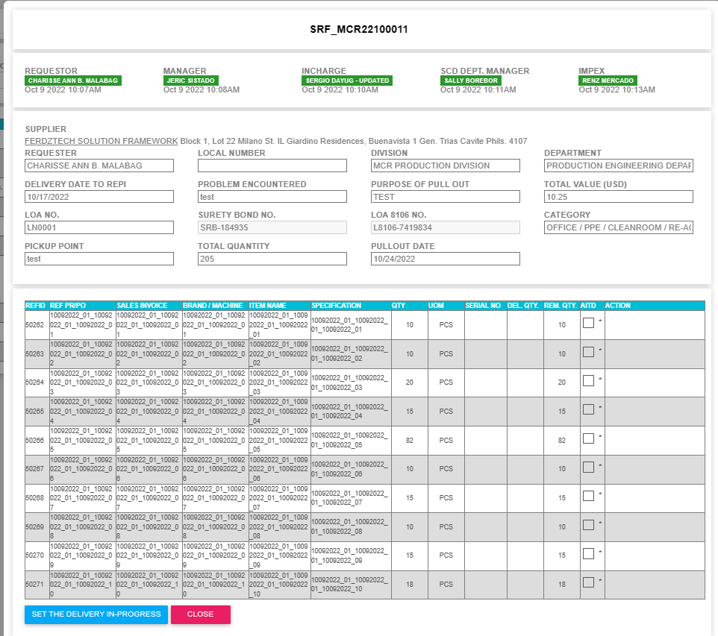

1. If delivery arrived at REPI, the user need to click the SET THE DELIVERY IN-PROGRESS to inform IMPEX through email that there is on-going delivery. Select the AITD or the ACTUAL ITEMS TO DELIVER before clicking the SET THE DELIVERY IN-PROGRESS.
2. After clicking the SET THE DELIVERY IN PROGRESS, IMPEX should received an email regarding the item details.



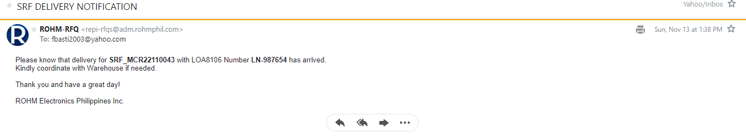

1. Confirmation message is being displayed after the setting the delivery in progress. There are 2 kinds of message confirmation. First is saying that it has been successfully move to delivery in-progress and impex has been notified. The second one is it has been successfully move to delivery in-progress and failed to notified impex due to connection issues.

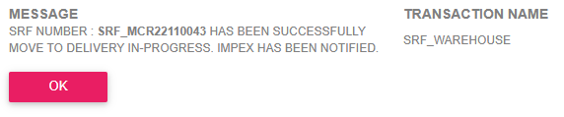

1. Status will change to DELIVERY IN-PROGRESS and item(s) to received is also displayed for monitoring purposes.



1. Once start receiving the item, double click the VIEW link to display the details and actual delivery.

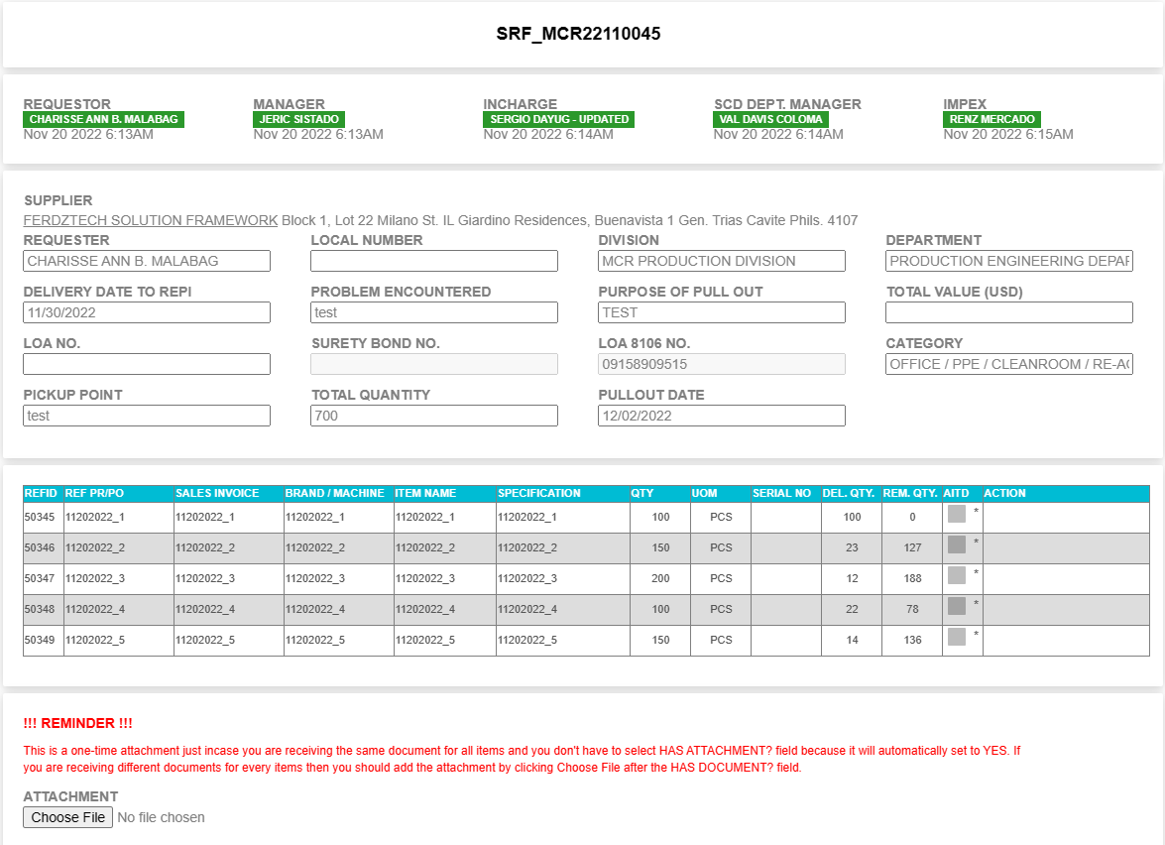

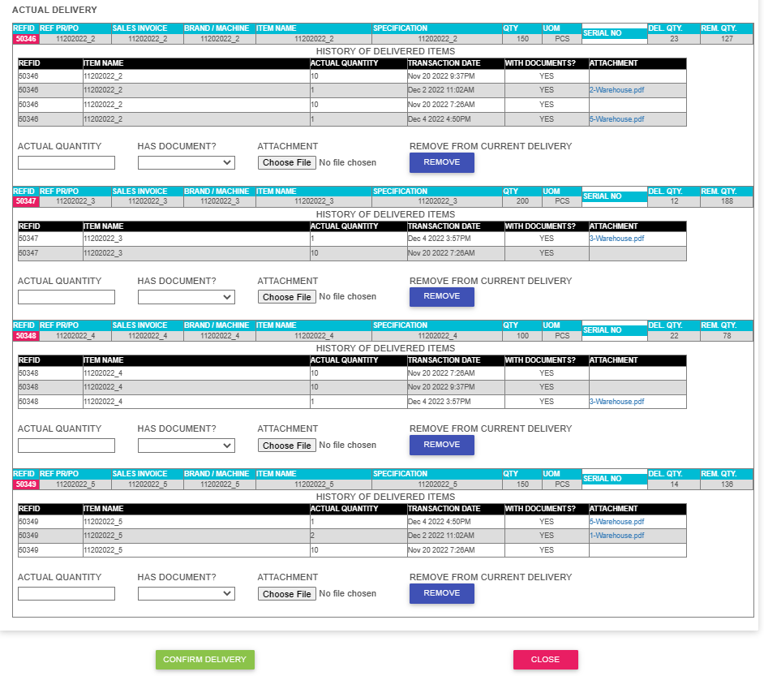

1. Enter the actual quantity, select has document? and choose attachment file if the related document is different from other items. If the document is the same for all items then click the choose file above and it will be use as attachment for all items and automatically set to YES for HAS DOCUMENT field (**READ THE REMINDER ABOVE FOR REFERENCE**)
2. Again you will received confirmation that the delivery has been successfully process. Impex has been notified.

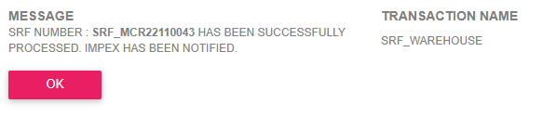

1. Impex will received and email regarding this actual delivery items.



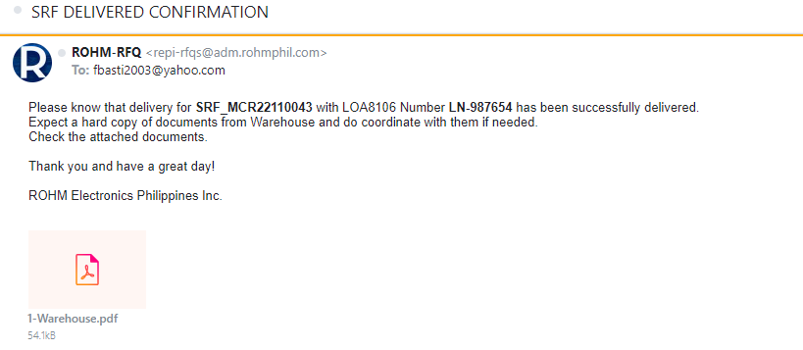

1. Ex. If the ordered items is 150PCS and the first delivery is 100PCS. When you go back to Warehouse Receiving Entry you will notice that the status of the request is DELIVERED WITH PENDING ITEMS.



1. Next step is go to 8105 Receiving Entry. SERVICE REPAIR > 8105 Receiving Entry. Double click the VIEW link in ACTION column to display the details.

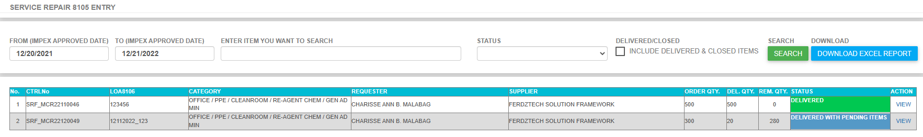

1. Make sure that you have entered the **8105/8112 NUMBER, 8105/8112 NUMBER PROCESS DATE**  and select the **attachment** file before clicking submit button. Please see highlighted in yellow.

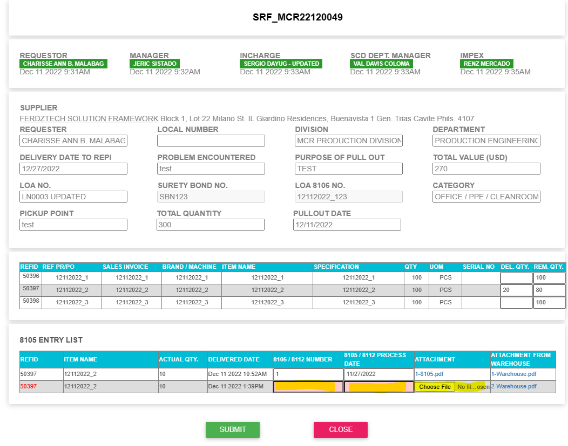

1. Confirmation will appear saying that 8105 is successfully added to specific SRF request or this transaction is liquidated. After clicking the OK button it will return to 8105 Receiving Entry but the item is gone in there because it was already liquidated.

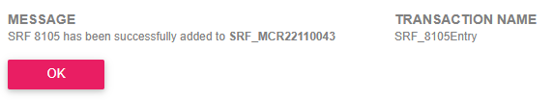

1. Repeat the process until the last item will close, delivered and liquidated.